**PRACTICAL-7**

**AIM:**

**a.** Create a python function to find all the unique elements in the list.

**Source Code:**

def find_unique_elements(input_list):

unique_elements = list(set(input_list))

return unique_elements

my_list = [1, 2, 2, 3, 4, 4, 5]

unique_elements = find_unique_elements(my_list)

print("Unique elements in the list:", unique_elements)

**Output:**

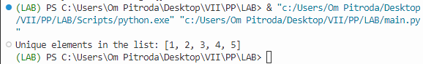

**b.** Create a python function to find all the duplicate elements in a tuple.

**Source Code:**

print("Duplicate elements in the tuple:", duplicate_elements)

**Output:**

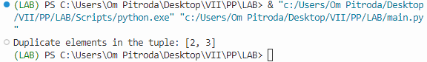

**c.** Write a program to create a function in python that compares two dictionaries and returns true or false accordingly.

**Source Code:**

e def compare_dictionaries(dict1, dict2):

return dict1 == dict2

dict1 = {'name': 'John', 'age': 30}

dict2 = {'name': 'John', 'age': 30}

dict3 = {'name': 'Alice', 'age': 25}

result1 = compare_dictionaries(dict1, dict2)

result2 = compare_dictionaries(dict1, dict3)

print("Result of comparing dict1 and dict2:", result1)

print("Result of comparing dict1 and dict3:", result2)

**Output:**

